Exercise: Java 8 Features

Q1) Write the following a functional interface and implement it using lambda:

* First number is greater than second number or not Parameter (int ,int ) Return boolean
* Increment the number by 1 and return incremented value Parameter (int) Return int
* Concatination of 2 string Parameter (String , String ) Return (String)
* Convert a string to uppercase and return . Parameter (String) Return (String)

Answer:

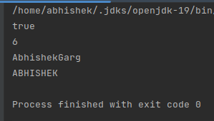

Q2) Using (instance) Method reference create and apply add and subtract method and using (Static) Method reference create and apply multiplication method for the functional interface created

Answer:

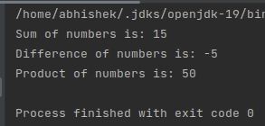

Q3)Create a thread using lambda function

Answer:

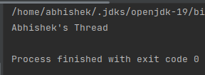

Q4) WAP using java 8:

* Collect all even numbers from a list using stream

Answer:

* Given a list of objects of following class:

class Employee{

String fullName;

Long salary;

String city;

}

Get list of all unique firstNames of employees where their salary is less than 5000 and who live in delhi.

Note: Full name is concatenation of first name, middle name and last name with single space in between.

Answer:

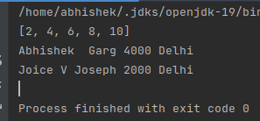

Q5)Implement multiple inheritance with default method inside interface.

Answer:

